ULTRASONIC THICKNESS MEASUREMENT REPORT
Company/Client: NCOC N.V. |  |  | Project: ESKENE WEST KARABATAN |  |  |  |  | Location: Oil Tranche 1
Line No/Tag No:  A1-2101-PW-021-3”-A17-HC |  |  | Component examined | Material |  | A333 Gr 6 |  | Probe sensitivity calibration
Procedure No:  QP-11-UTT-Q01 Rev 00 |  |  | Component examined | Día X Nominal Thickness |  | 3” x 11.12 mm |  | Probe S/N |  | 925365
 |  |  | Component examined | Operating Temp |  | Ambient |  | Angle |  | 0º
Manufacturing Code/Acceptance Standard:  ASME B31.3 / Client Specific |  |  | Reference Calibration Block Details | Block |  | CS Step wedge |  | Frequency |  | 5 MHz
 |  |  | Reference Calibration Block Details | Range |  | (6.25-25 mm) |  | size |  | 11 mm
Method: Contact |  |  | Reference Calibration Block Details | Accuracy |  | 0.025 mm |  | Crystal |  | Dual
Surface condition: Coated |  |  | Reference Calibration Block Details | Temperature |  | 32.86 ºC |  | Reference sensitivity |  | 2nd backwall reflection to 80% FSH
Couplant: Gel |  |  | Correction factors |  |  | n/a |  | Scan Sensitivity |  | Reference dB
S. No | Equipment/  Material Name | Manufacturer |  |  | Serial No |  | Calibration certificate No |  | Calibration Expiry date
 | A-scan UT | OLYMPUS DL-38 |  |  | 171421601 |  | 2113237 |  | 01-04-2018
 | Step wedge calibration block | OLYMPUS |  |  | 145414 |  | - |  | -
Job description:

- UT scanning has been carried out on 3”Ø elbow at 3-6-9 O’clock position and spot reading taken at 12 O’clock position.

Legend:
FSH: Full Screen Height, N/A: Not Applicable

DETAILS AND RESULTS
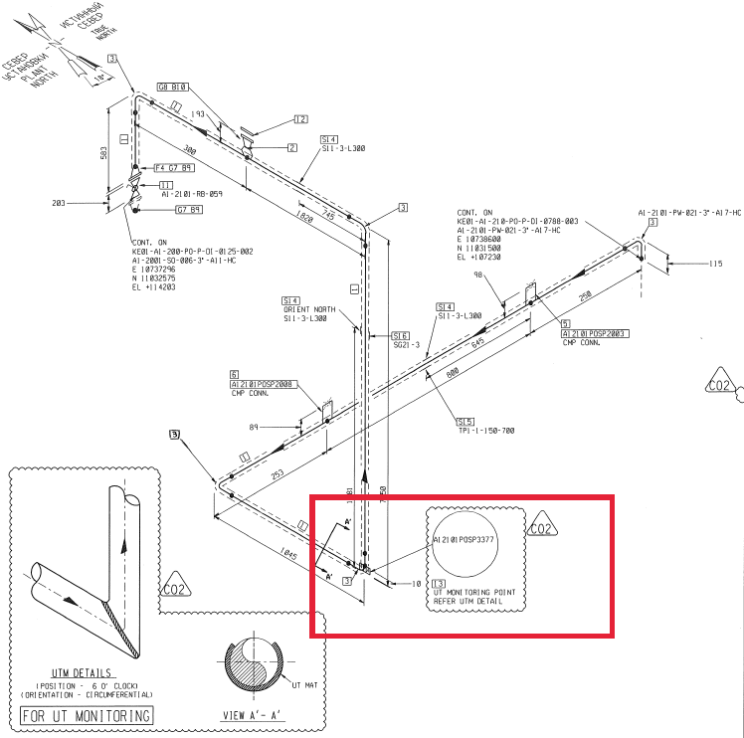
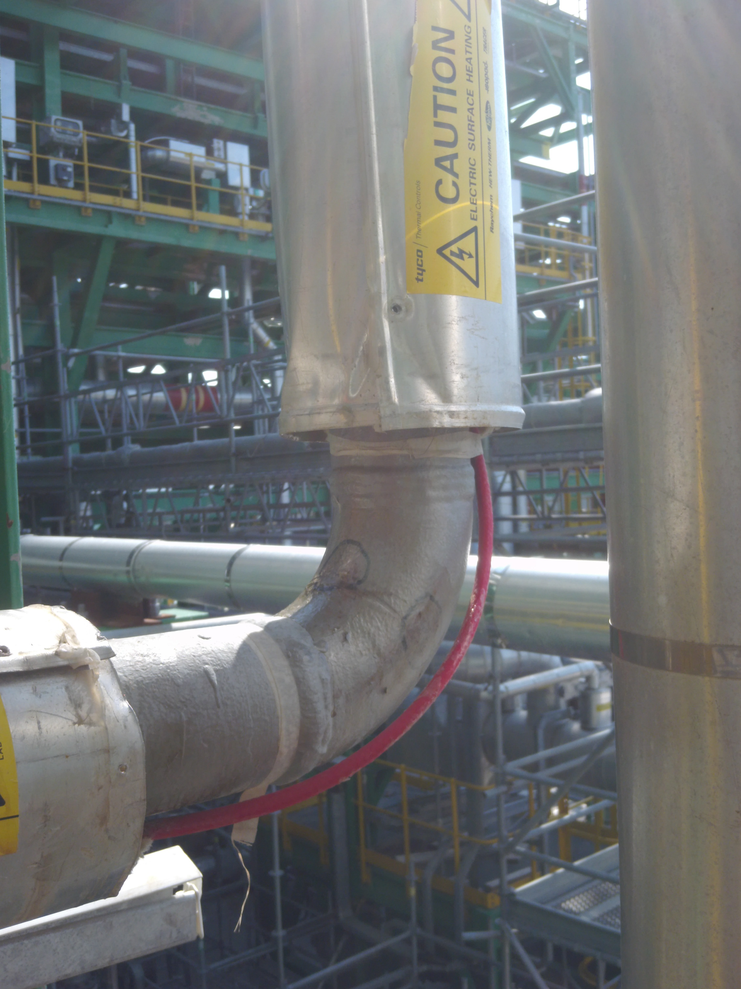
Minimum thickness observed on extrados 10.8mm

S/NO | Inspection date | Item description | DIA(Ø) | East | North | West | South (6 o’clock)-Extrados
1 | 28-11-2017 | Elbow | 3” | 12.0 | 12.0 | 11.7 | 10.8
2 | 26-02-2018 | Elbow | 3” | 12.0 | 12.0 | 11.7 | 10.8

APPROVALS:
UT L II cert. #403  expire date 14.05.2018 | Name: Dosbatyrov Damir | Signature:................................................. | Date: 26.02.2018
UT L III cert. #225809  expire date 30.04.2019 | Name: Adinarayana Malavathu | Signature:................................................. | Date: 26.02.2018
Client Representative: | Name:…………………………………… | Signature:................................................. | Date: …………………………

